Greek Theatre Notes

Dionysus
- God of wine and fertility
- Greek theatre came out of the worship of Dionysus
- Major Theatre festival was called City Dionysia

Thespis
- According to Aristotle he was the first actor to appear on stage
  - Other sources say he introduced the first character OTHER than the chorus.
- Introduced idea of masks to portray different characters.
- Won the first tragedy competition
- Thespians

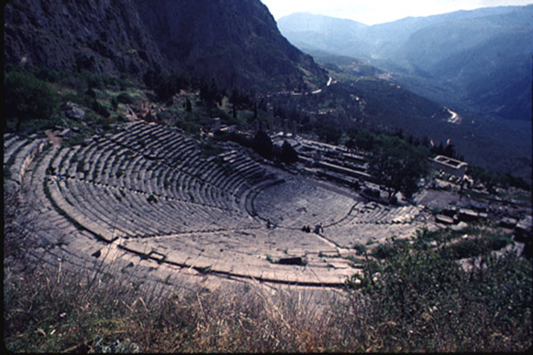
Greek Ampitheatre
- Open air space using sloped hillside for seating
- Placed near sanctuaries
Orchestra – “the dancing space” for the chorus, chief performance space, circular.
Thymele - An alter to Dionysus was generally placed in the middle of the orchestra
Theatron – “the seating place” semi-circled terraced area with benches (built with wood or stone)
- Sight not great but acoustics excellent, words spoken silently in orchestra could be heard all the way up.
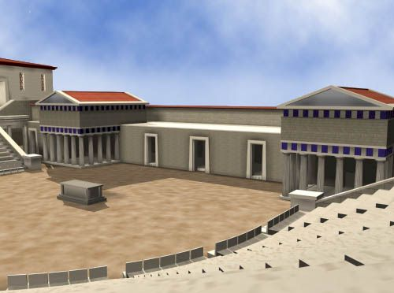
Skene – “tent” covered structures where actors stored costumes and masks (originally temporary wood structure eventually stone) and performed quick changes out of sight.
*Upper platform
Paraskenia – “beside the skene” wings on the side
*Chorus stayed in the orchestra but actors used skene to make entrances and exits
Proscenion – platform in front of the skene
Parodos – “passageways” actors took to enter and exit the proscenion. Ramps on the side of stage between skene and audience.
Greek Festivals
- Largest and most prolific of festivals was City of Dionysia or Great Dionysia
- Held late March – Early April
- Singing, dancing, satyr costumes, and lots of wine drinking to worship god Dionysus
- Parade to carry a stature of Dionysus to the Acropolis
Competition of theatre tragedies
- Three playwrights competed
- Thought to have to submit 3 tragedies (in a trilogy) and a satyr
  - Related By:
    - Theme
    - Myth
    - Character
*3 days of the competition, one for each playwright
*Put to a vote

Greek Playwrights
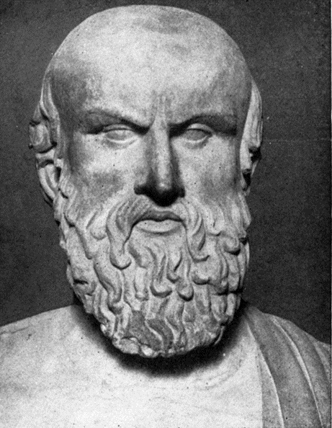
Aeschylus (523-456 B.C.E.)
- “The Father for Tragedy”
- Oldest plays surviving
- 7 of 80 plays remaining
  - Only surviving trilogy Orestia (Agamemmnon, Libation Bearers, Eumenides)
- Winner of the Festival of Dionysus 13 times
Contributions
- First to add a second actor to allow for dialogue
- First to allow chorus to be part of the action

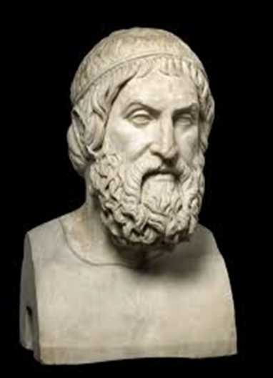
Sophocles (496-406 B.C.E.)
- Considered “best of the three”
- Won 24 contests at festival
- 7 of 120 plays survived
- Oedipus the King “perfect Greek tragedy”
- Allowed his characters to question the fate and will of the Gods
Contributions
- Addition of a 3rd actor
- Limit chorus to 15 actors
- First use of scene painting

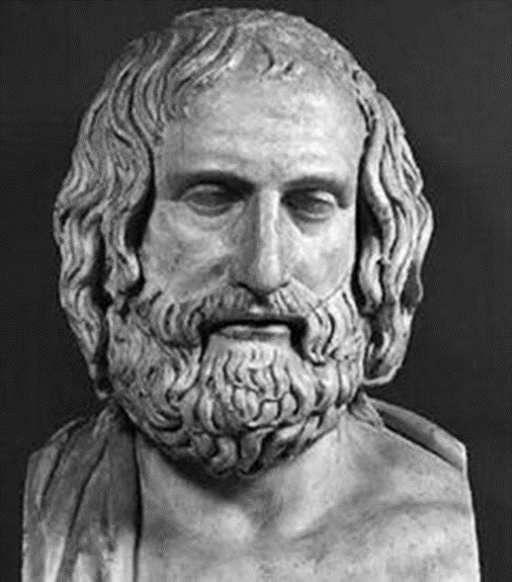
Euripides (480-406 B.C.E.)
- Won festival only 4 times
- 18 plays survived
- Most unique of the three
- Mainly minor myths or greatly changed major myths
- Known as the Master of Pathos (Human compassion and sorrow)
Contributions
- First to combine tragedy and comedy elements
- Only surviving satyr play Cyclops
- Wrote Medea

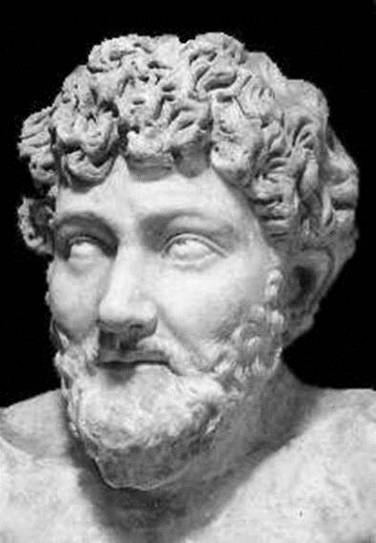
Aristophanes (446-386 B.C.E.)
- Known for his Satyr’s.
- Wrote 40 plays,11 plays survived

Contributions
- The Frogs
- The Clouds
- Lysistrata

